**Amortization Schedule**

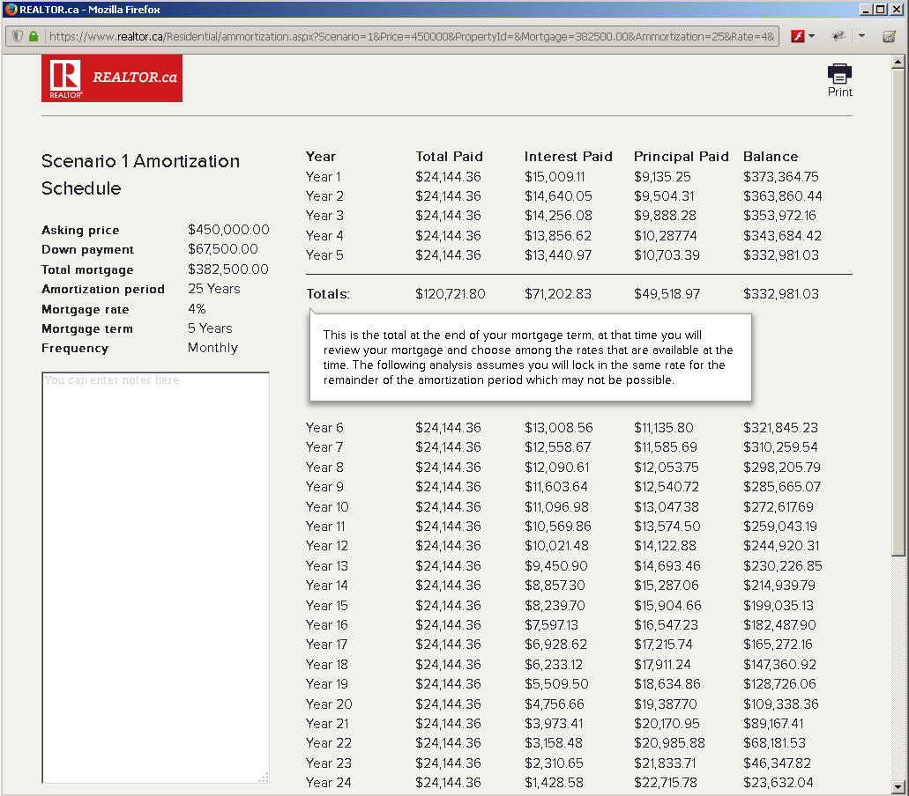

What type of mortgage is best for you?

•

Fixed rate mortgages: Your interest rate

is locked in for a specified period called a

term. Your payments stay the same for the

mortgage’s term so you will not pay more

if interest rates increase over time.

•

Variable rate mortgages: Rate of interest

you pay may change if rates go up or down.

•

Conventional mortgages: Require a

down payment of 20% or more of the

property’s value. You are not required to

get mortgage default insurance with a

conventional mortgage.

•

Closed mortgages: The mortgage cannot

be paid off early without paying a

prepayment charge.

•

Open mortgages: A mortgage that can

be paid off at any time during the term,

without having to pay a charge. The

interest rate for an open mortgage may be

higher than for a closed mortgage with the

same term.

Are you planning to purchase a

property with less than a 20%

down payment?

If yes, you require mortgage default

insurance which generally adds 0.6%

to 3.85% to the cost of the mortgage

depending on the total amount borrowed.

Mortgage default insurance enables you

to purchase a home with a minimum

down payment of 5% (10% for multi-unit

dwellings) with interest rates comparable to

those of a conventional mortgage.

Major providers of mortgage default

insurance include Canada Mortgage and

Housing Corporation (CMHC), Genworth

Canada, and Canada Guaranty Mortgage

Insurance Company.